American Revolution Event Tweet (Pt.1)

Directions:
- Write down the event that was assigned to you in the first box below.
- Using Britannica Online or Wikipedia or Simple English Wikipedia, find the following information about your event(s):
Event Name
When did the event take place?
How did the event affect the American Colonists?
(Explain in complete sentences)
How might the British Government React to This Event?
(Explain in complete sentences)
Summarize your event in 140-200 characters
3 Important Terms
(ex. people, places, things)
Draw an Icon Which Represents Your Event
Explain Your Icon
(in 1-2 sentences)

Sample

Event Name | ‘Common Sense’ by Thomas Paine
When did the event take place? | January 6, 1776
How did the event affect the American Colonists?  (Explain in complete sentences) | Those colonists who read the pamphlet written by Paine felt angered towards the British government and how it had abused the American Colonists over time
How might the British Government React to This Event?  (Explain in complete sentences) | The British government would be upset over it’s citizens wanting to rebel against it. It might want to send soldiers over to protect what they believe is theirs (the colonies).
Summarize your event in 140-200 characters | Common Sense was a pamphlet written by an American colonist named Thomas Paine. It heavily criticized the English government and its ill treatment of the colonists and asks for them to fight for independence from England. (186)
3 Important Terms  (ex. people, places, things) | - Pamphlet: A short book  - Independence: Self-rule  - Tyranny: Oppressive governmental rule
Draw an Icon Which Represents Your Event | 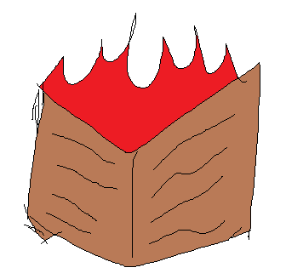
Explain Your Icon  (in 1-2 sentences) | The drawing is of a book on fire, representing how Thomas Paine’s pamphlet ignited the colonists’ passion for independence from England.

