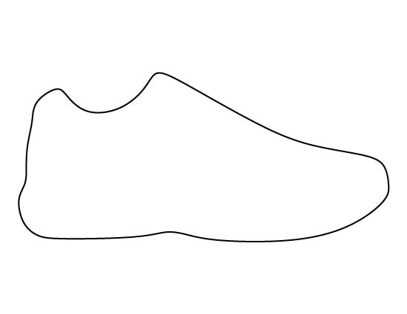
Event Title
Event Date

Summary
American Colonist’s Reactions
British Government’s Reactions

