World History
Letter from a WWI Soldier – Letter

Directions:
You will begin writing your letter using the information you have researched about your battle, the technology, and your character’s background. Using the formatting shown in the examples on the website, write a letter to an imagined loved one from one of the major battles of World War I.

Letter Format:
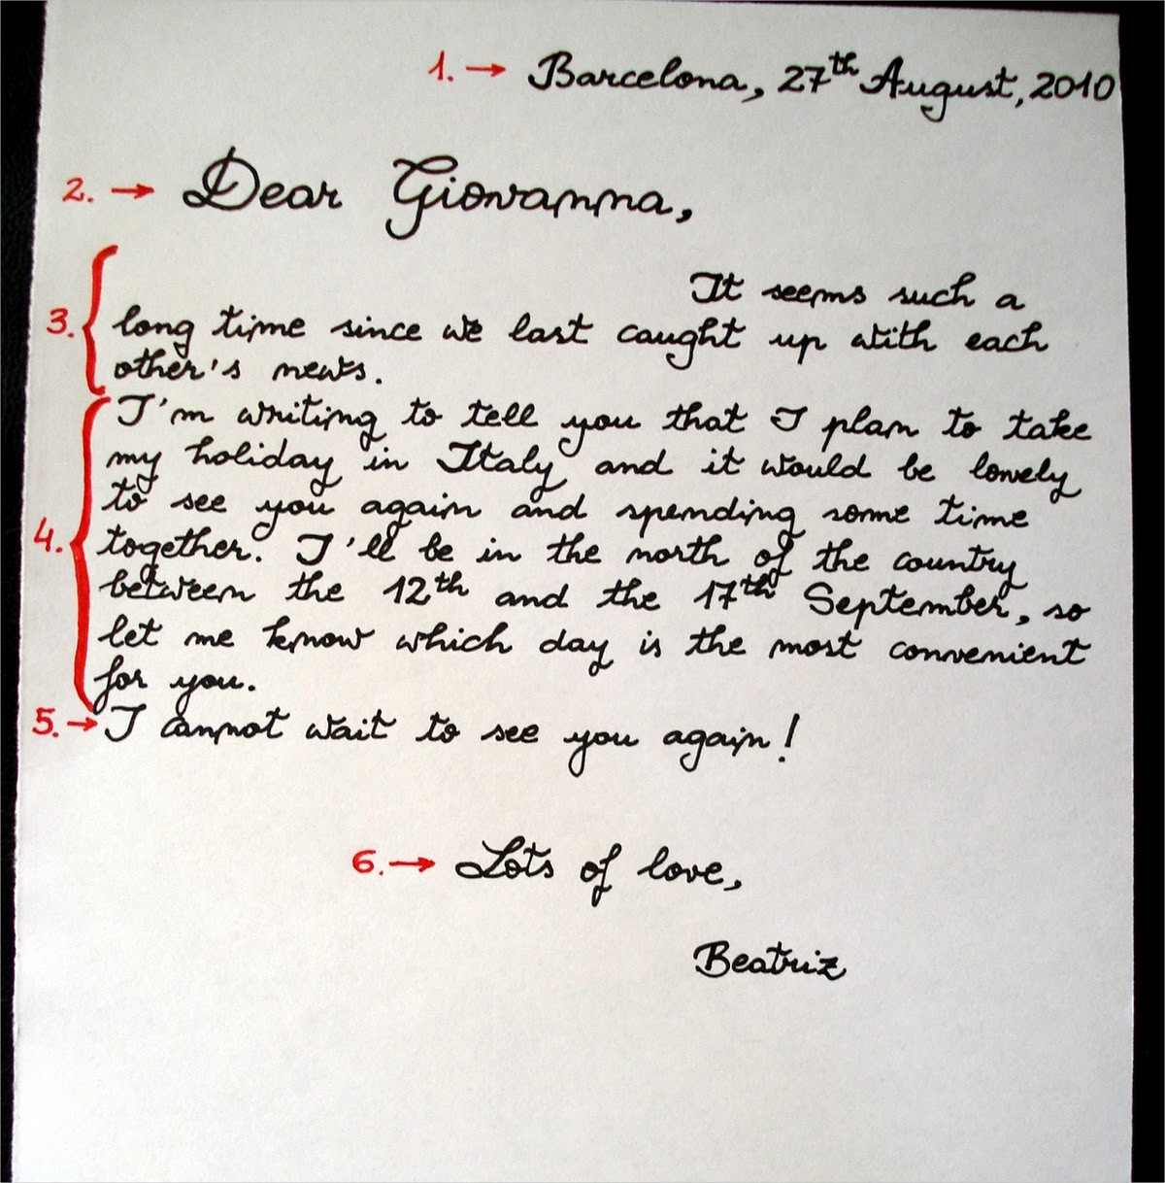
Letter Format Breakdown
- Location + Date Written

- Greeting (“Dear …,”, “Hello…,”, etc.)

- Introduction paragraph

- Main body paragraph

- Closing statement

- Closing signature (“Sincerely,…”, “Love,…”, etc.)

Requirements of the Letter
- 150-200 words
- Written as a letter
- Discusses the following topics:
  - Where your character is (location) and what is happening around you
  - What type of things your character has seen or encountered in war (including technology)
  - Your character’s thoughts on war in general
  - What your character misses about life outside of war
  - Your character’s hopes and dreams

